Project Report

**Water Overflow Level Indicator**

**Theory:**

Water overflow level indicator is a device that stop the water tank from overflowing. The purpose of a water level indicator is to gauge and manage water levels in a water tank. The Water overflow Level Indicator employs a simple mechanism to detect and indicate the water level in an overhead tank or any other water container. We have made a simple water overflow level indicator which can be used in our Home and factories etc.

Water is very important in our daily life. We cannot imagine our daily life without water. However now in modern days in hotels, factories, Homes and Cooling towers we store the water in tanks by water pump for use. Sometimes the water tank overflown by water while storing the water in it, because the water tank has limited storing capacity. For this lots of water becomes waste. For preventing from waste of water, water overflow level indicator is very important. For using water overflow level indicator, it saves waters, electricity and money.

The working principle of a water overflow level indicator is actually quite simple. Water overflow level indicators work by **using sensors** to indicate water levels in a storage tank. These sensors send information back to the control panel to trigger an alarm or indicator.

**List of Equipment:**

1. 100ohm Resistors.
2. BC547 NPN
3. Buzzer.
4. LED.
5. 9V Battery.
6. Switch.
7. Cable.

**Circuit Design & working procedure of Water Overflow Level Indicator:**

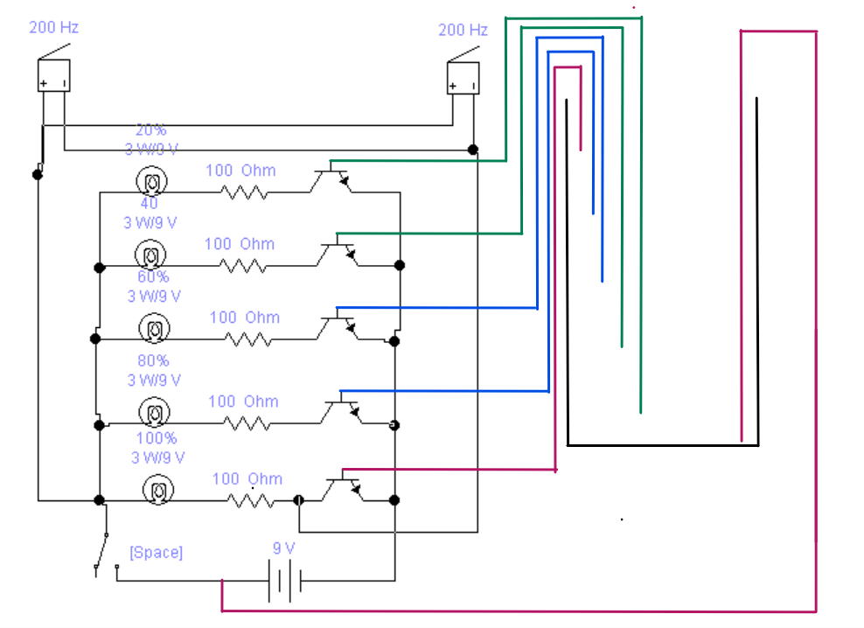

A water-level-controller circuit monitors the level of the overhead tank and spontaneously switches on the water pump whenever the level goes below a specific limit. The level of the overhead tank is indicated using 5 LEDs, and the pump is switched off when the overhead tank gets completely filled up. The water level controller circuit does not allow the pump to start if the water level inside the sump goes low, and switches off the pump even during the pumping period if the water level inside the sump sinks low while the process of pumping the water towards the overhead tank continues.

The above-mentioned circuit consists of five probes arranged in an overhead tank and is interfaced with five BC457 NPN transistors. The probes are arranged in such a way that they sense 20%, 40%, 60%, 80% &100% are full levels as they are placed with equal spacing one above the other with the bottom positive probe. A positive voltage supply is placed at the bottom of the overhead tank, and a full-level probe is placed in the tank and the other end is connected to the base of the transistor BC457 NPN through a resistor R1k.

Whenever the water level rises to the20%, then current flows through the base of the transistor and the collector voltage becomes low and is interfaced with the port p0.0. Then sends the data to the LED. D1 indicates the level and blink this LED D1. Whenever the water level rises to the40%, then current flows through the base of the transistor and the collector voltage becomes low and is interfaced with the port p0.1. Then sends the data to the LED. D2 indicates the level and blinks this LED D2. Whenever the water level rises to the60%, then current flows through the base of the transistor and the collector voltage becomes low and is interfaced with the port p0.2. Then sends the data to the LED. D3 indicates the level and blink this LED D3. Whenever the water level rises to the80%, then current flows through the base of the transistor and the collector voltage becomes low and is interfaced with the port p0.3. Then sends the data to the LED. D4 indicates the level and blink this LED D4. Whenever the water level rises to the100%, then current flows through the base of the transistor and the collector voltage becomes low and is interfaced with the port p0.4. Then sends the data to the LED. D5 indicates the level and blink this LED D5. The P0.4 stage indicates the maximum level of the water. and then the motor switches off manually.

The ports P0.0, P0.1, P0.2, P0.3, and P0.4 are interfaced with the LEDs for the purpose of indicating the levels and are connected to the resistors. The port P0.0 is used to control the pump and connect to the LED D5 as an indication of max level in the tank and the LED glows and the buzzer is on.

**Procedure:**

* We Connected the 9V Ac supply at Input terminals.
* We are Keeping the buzzer on the Top Alarm On position.
* If we Connect the Green sensor at L1 and dip it in water — 1st Led (20% level) will glow)
* If we Connect the Green sensor at L2 and dip it in water — 2nd Led (40% level) will glow.
* If we Connect the Blue sensor at L3 and dip it in water — 3rd Led (60% level) will glow.
* If we Connect the Blue sensor at L4 and dip it in water — 4th Led (80% level) will glow.
* If we Connect the red sensor at L5 and dip it in water — the 5th Led (100% level) will glow and the Top-level alarm will start.

**Water overflow level Indicator Project Diagram & description:**

Output

Transistor

BC457 NPN

Main

Circuit

Switch

Input

Here DC power supply by the supply line through switch is given to the main circuit. Which is connected by led Indicator, Sensors and Buzzer. When the switch is turned on DC power enter in the circuit. The main circuit is made with Resistors, and IC’s. One side of the sensors are connected with the led Indicator through Resistors and IC’s and the other side are placed inside of the water tank. Inside of the tank the sensors are placed in different level of the tank. When the water level will become low the Red led will turn on and when the water level become full inside of the tank then the Green Led and Buzzer will turn on by indicating that the water tank is full.

**Project Picture:**

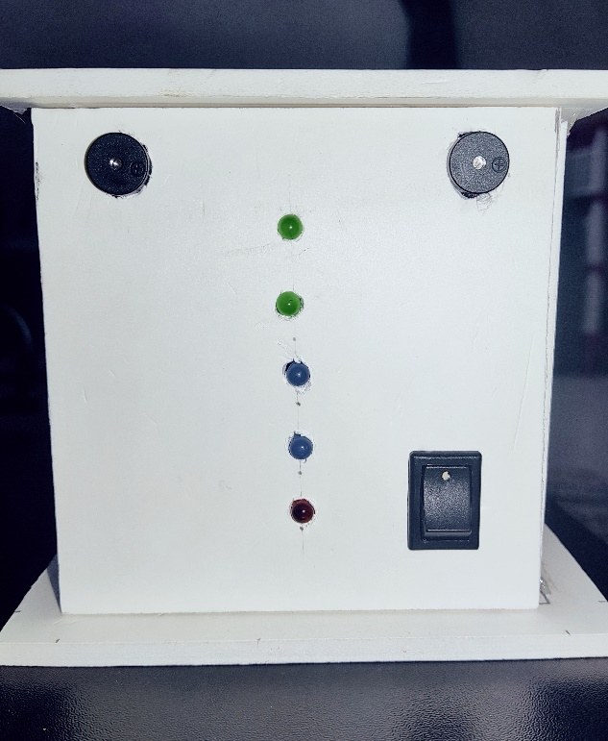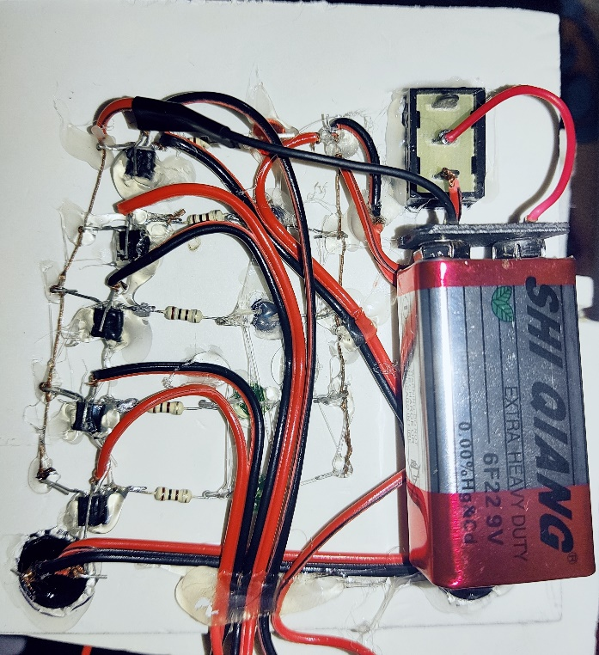

**Applications:**

* Water level indicators used to prevent water wastage.
* This can be water tank overflow alarm system.
* This can be used show water tank level.

**Limitations:**

* Manually on of water motor.
* Manually on of circuit system.

**Discussion:**

Water overflow level indicator system is an awesome technology by which you can monitor, control your home water tank. This Project is user friendly and it can be easily maintained. This project saves your time and money, and will help prevent water wastage.